2) Investigate the purpose and requirements of the secure network according to the given scenario?

The answer:
The purpose of the secure network in this scenario is to establish a reliable and secure communication infrastructure for TechGlobal. The company is expanding its operations to multiple locations and it needs a network that ensure the CIA of it data and services.

The requirement for the secure network :
1-Vpn/IPsec site-to site connection:
Establish a secure VPN with Ipsec connectively between Amman data centre and remote offices outside the Jordan this ensure a private and encrypted communication channel over the internet.

2-hardening for switches and routers:
Implement secure measuring for all switches and routers include:
-use strong passwords for device access.
-using SSH instead of telnet for secure remote access.
-shutdown any unused port to reduce attack surface.
-apply port security with a maximum mac address of two.
-implement DHCP security to protect against spoofing and starvation with rate limit 5.

3-dynamic Ip address:
Configure dynamic Ip for devices in the HQ data centre subnet, except for server, pc1,and gateway witch must be a static IP address.
4-routing:
Implement a dynamic routing instead of static routing to enable efficient and scalable network communication.
5-server access control:
Define access rules for server in VLAN 15 to unsure appropriate access levels:
HTTPs server: Accessible by all VLANs and LANs.
Mail server: Accessible by all VLANs and LANs.
DNS server: Accessible by all VLANs and LANs.
FTP server: Accessible only by HQ EMP and Aqaba office.
DHCP server: Accessible only by HQ datacentre VLAN.
HTTP server: Accessible only by HQ EMP LAN.
6-local AAA authentication for ssh:
Implement local AAA authentication for VTY lines on the Tunisia router using ssh set up username and password.
7-disaster recovery site (Aqaba office):
Using ASA firewall instead of a router for enhance security.
8-firewall configuration (Aqaba ASA):
Allow ssh service on Aqaba ASA firewall only from HQ data centre pc1 (15.0.0.10)
Configure DMZ for VLANs.

This requirement aims to create a secure, scalable and efficient infrastructure for TechGlobal Inc.

3) Determine which network hardware and software to use in the network?
The answer:
These are some things that can be used on the network:
Network hardware:
1-router:
Using cisco ISR series routers for the HQ data centre and remote offices.
Consider cisco ASA for firewall functionality.
2-switches:
Apply switches for both HQ datacentre and remote offices.
3-firewall:
Consider cisco ASA for firewall services especially the Aqaba disaster recovery site.
4-vpn devices:
For VPN connectivity use router with VPN capabilities or dedicated VPN appliance.
Consider cisco VPN routers or ASA devices for site-to-site VPN.
5-servers:
Standard servers for hosting services like HTTP,HTTPS,FTP,DHCP and DNS.
For redundancy consider using multiple servers in the data centre.
6-network cabling:
Use a high-quality ethernet cables for wired connection.
7-ASA firewall for Aqaba disaster Recovery site:
Deploy cisco ASA firewall to provide security services for the Aqaba disaster recovery site.
Network software:
1-VPN software:
Configure VPN using IPsec protocol on routers or dedicated VPN devices.
2-firewall configuration:
Implement firewall rules using the Cisco ASA operation system for security policies.
3-firewall configuration:
Implement firewall rules using the Cisco ASA operating system for security policies.
4-Security Features:
Leverage built-in security features of Cisco devices, including ACLs (Access Control Lists), SSH, and AAA for authentication.
5-DHCP and DNS services:
Use DHCP and DNS services provided by the server operating systems or consider Cisco devices for these services.

4-Examine the various categories of devices employed for ensuring network security?
The answer:
1-Firewall:
Purpose: firewall acted as a barrier between a trusted network and untrusted external network such as internet
Functionality: they inspect, and control incoming and outgoing network traffic based on security rules.
2-Virtual private network (VPN):
Purpose: VPN concentrator facilities secure remote access to private network over the internet.
Functionality: they manage and establish VPN connections ensuring the data transmitted between remote users and the internal network is encrypted and secure.
3-intrusion detection system (IDS):
Purpose: IDS monitor network and/or system activates for malicious activities or security policy violation.
Functionality: IDS can be either network-based or host-based. Network based IDS analyse network traffic for suspicious patterns, while host IDS monitor the activities on individual devices.

4-Distributed Denial of Service (DDoS) Mitigation Appliances:
Purpose: DDos mitigation devices protect against large-scale coordinated attack that attempt to overwhelm a network or services.
Functionality: they identify and mitigate DDos attacks by filtering or diverting malicious traffic ensuring the availability of network resources.

5- Analyze the network security protocols and the application/discussion of distinct cryptographic
methodologies/types within the domain of network security?
The answer:
network security protocol:
1-secure sockets layer (SSl) / transport layer security (TLS):
Purpose: encrypts data in transit between clients and servers ensuring secure communication.
Application: used in web browsing (HTTPS), email and various other secure communication channels.
2-internet protocol security (IPsec):
Purpose: provides network-layer security by authentication and encrypting IP packets.
Application: site-to-site VPN, remote access VPNs, secure communication between routers.
3-seucre shell (SSH):
Purpose: provide secure encrypted communication over an unsecured network.
Application: remote administration of network devices, file transfer and secure command-line access.
4- The Point-to-Point Tunnelling Protocol (PPTP) and Layer 2 Tunnelling Protocol (L2TP):
The purpose is to create virtual private networks (VPNs) for secure internet communication.
Application: VPNs are used for remote access.
Cryptographic methodologies:
1-symmetric encryption:
Description: uses a single key for both encryption and decryption.
Application: bulk data encryption due to its speed used in protocol like IPsec and SSL.
2-asymmetric encryption (public key cryptography):
Description: uses a pair of keys (public and private) for encryption and decryption ].
Application: key exchange (Diffe-hellman), digital signature(RSA) secure communication (SSl).
3-hash function:
Description: generate a fixed-size hash value from input data. Irreversible
Application: data integrity verification password storage digital signature.
4-digital signature:
Description: uses asymmetric encryption to provide authentication and integrity verification.
Application: verifying the origin and integrity of message documents or software.
5-public key infrastructure (PKI):
Description: establish a framework for secure communication using public key cryptography.
Application: certificate authorities’ digital certificate secure emails, SSL.
6-DIFFE-Hellman key exchange:
Description: enable two parties to securely exchange cryptographic keys over an insecure channel.
Application: key exchange in SSL/TLS, Ipsec and other secure communication protocols.
7- Elliptic Curve Cryptography (ECC):
Description: utilized elliptic curves to provide strong security with shorter key lengths compared to traditional algorithms.
Application: SSL/TLS, encryption, digital signatures.
8-one time paid:
A potentially unbreakable encryption system that use a randomly generated key just once.
Application: Rarely used owing to key distribution issues but gives complete security when correctly done.

7. Configure Network Security measures for your network. Those measures include Firewalls,
Routers, Switches, Gateways, passwords, SSH, SSL, IPSec, VPN, HTTPs, FTPs, DHCP and
DNS. And provide a justification for the choices made in the network security configuration that
was implemented along with the network security configuration scripts/files/screenshots with
comments?

The answer:

Here the switch I gave a port to each VLANs the native VLAN I put the unused ports inside it.
Each interface has switchport access between the switch and the pc to specify the ports for each vlan
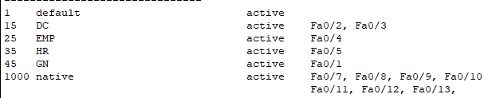

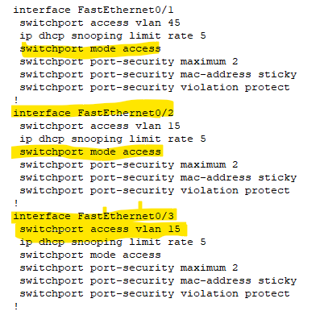

Here is the trunk between the switch and the router it allows more than one vlan types to pass through.

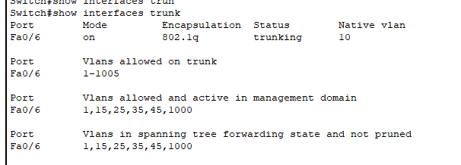

Now here is the sub interface I applied in router for the VLANs I took the original interface and divided it into more than one interface each sub interface will be specific to VLAN.
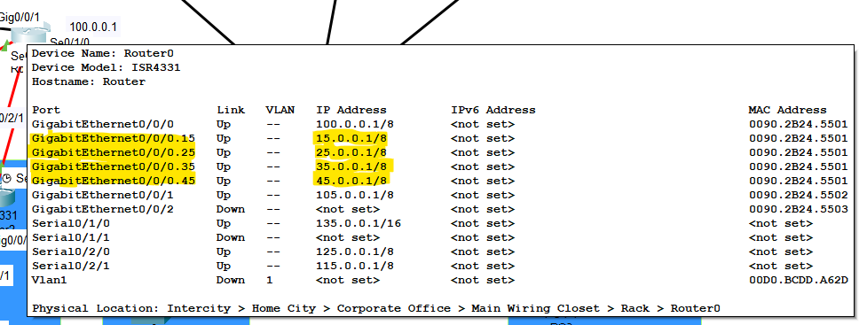

in every router I apply a password the password is: hashem.
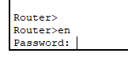
In router Tunisia I configure Local AAA Authentication for VTY Lines for SSH protocol.
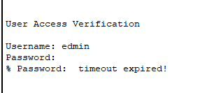

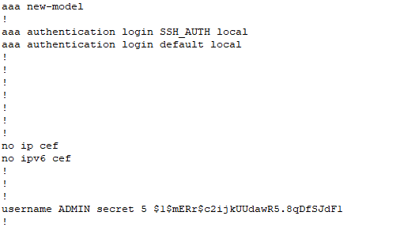

In every switch is shutdown the unused ports:
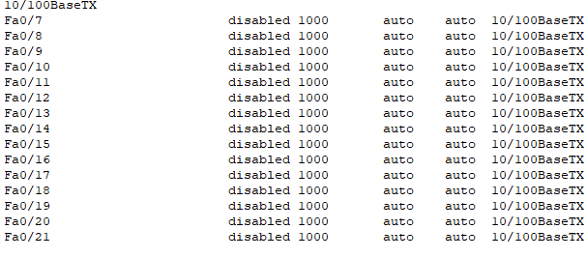

applying port security with maximum MAC address of two in every switch(determine each port how many MAC address it connect to) and apply dhcp snooping
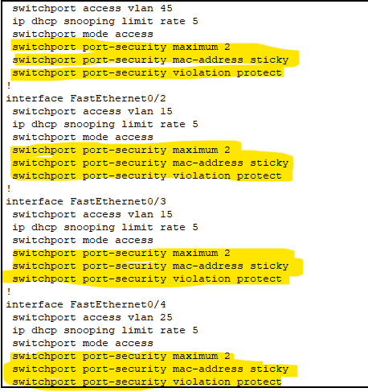
VPN site-to-site:
Router turkey:
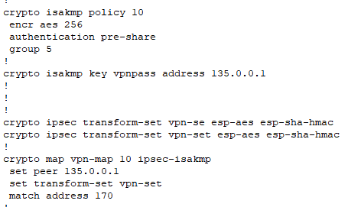

Router Tunisia:
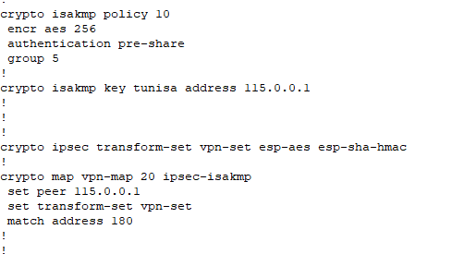
Router Kuwait:
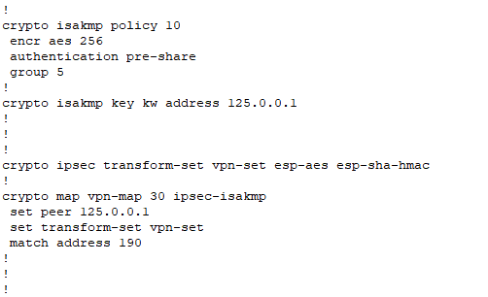

Router Amman:
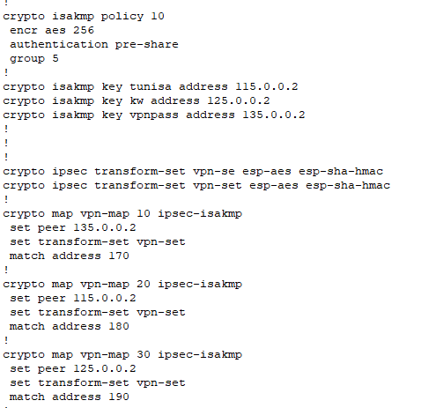
I use ACL for VPN site to site:
Router turkey:
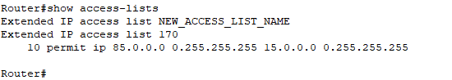

Router Tunisia:
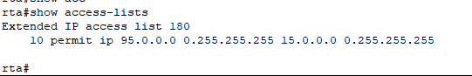
Router Kuwait:
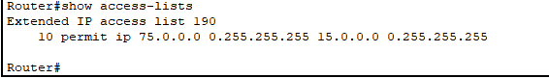

Router Amman:
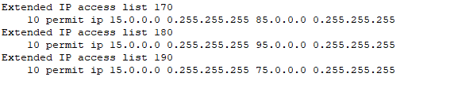

Apply ACl in router amman:
HTTPs server is accessible by all VLANs and LANS.
Mail server is accessible by all VLANs and LANS.
DNS server is accessible by all VLANs and LANS.
FTP server is accessible by only the HQ EMP, and Aqaba office.
DHCP server is accessible by only HQ datacenter VLAN.
HTTP server is accessible only by HQ EMP LA

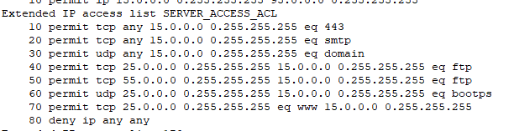

Firewall ASA configuration:

The first thing names the interfaces and put the secure measure:
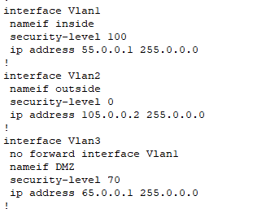

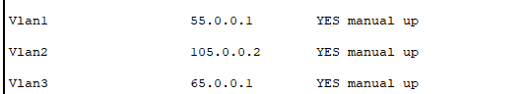

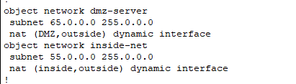

Using Nat from the inside to outside and from the DMZ to outside:



Apply inspection (track the traffic):
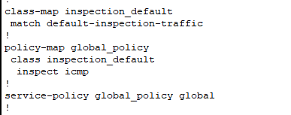
SSH service on Aqaba ASA firewall is accessible only by HQ Datacentre PC1 (15.0.0.10):
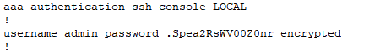
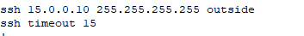

Apply Access list so the outside that have secure measure 0 can ping and browse in the devices inside the DMZ that have secure measure 70.

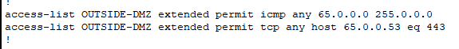

8)Draw comparisons and contrasts between at least two significant network security protocols:

The answer:

SSL/TLS:
Purpose: SSl/TLS protocol are designed to provide secure communication over a computer network, ensuring data confidentiality and integrity.
Usage: wide used in securing web transactions email communication and various other application.
Encryption: SSL/TLS use asymmetric encryption for key exchange and symmetric encryption for data transfer.
Authentication: SSL/TLS support server and optionally client authentication using digital certificates.
Port: on port 443 for secure HTTPS.

IPsec:
Purpose: IPsec is a suit of protocol used to secure internet protocol (IP) communication by authenticating and encrypting each IP packet.
Usage: primarily employed in VPNs for secure communication over the interment
Encryption: utilized both symmetric and asymmetric encryption algorithm for data confidentiality.
Authentication: support various methods for authentication including pre-shared keys and digital certificates.
Integration: IPsec can be implement at the network layer ensuring security for all traffic whereas SSL/TLS operates at the application layer.
Comparison:
-Both SSL/TLS and IPsec aim to provide secure communication but they operate at different layer of the OSI model (SSL/TLS at application layer, IPsec at the network layer).
-both protocols use encryption and authentication mechanisms to ensure data confidentiality and integrity.

Contrast:
-SSL/TLS is commonly used for securing web applications and services while IPsec is frequently used for securing network-level communications especially in VPNs.
-SSL/TLS is often implemented in the application layer making it more flexible for specific uses cases whereas IPsec operates at the network layer providing a broader level of security.
-SSL/TLS uses asymmetric encryption for key exchange while IPsec can use both asymmetric and symmetric encryption for different purpose.

9. Evaluate the importance of network security to an organization.
The answer:
Network security is very important for many reasons, including confidentiality and maintaining private information, and these are some of the importance of network security.
1-Confidentiality Protection:
Network security ensures that sensitive data, such as customer data and financial records, remains confidential.
2-intergirty assurance:
Network security measures help prevent unauthorized manipulation or modification of data during transmission or storage and maintain data accuracy.
3-avalibality:
Network security provides guarantees against attacks such as DDos attacks that may lead to disruption of the availability of services.

Part2) Evaluation and testing of network security through the implementation of a Test Plan.

1. Create a test plan for your network. Your test plan should consider different testing methods in
terms of checks on network security, testing for network vulnerabilities etc?

the answer:
test plan:
1-connectively tests:
-verify connectively between HQ datacentre devices.
-ensure connectively between remote offices and HQ datacenter.
-confirm connectively between remote offices
2-VPN/IPSEC site-to-site connection:
-establish and test the VPN/IPSEC connection between HQ data centre and remote offices.
3-hardening test:
-test strong passwords in routers and switches.
-ensure unused ports are shut down on all devices.
-validation port security with maximum mac address of two
-test DHCP security to protect from spoofing and starvation with a rate limit of 5.
4-routing test:
-confirm proper routing between different subnets.
-validation dynamic routing protocol
5-server accessibility tests:
HTTPs server is accessible by all VLANs and LANS.
Mail server is accessible by all VLANs and LANS.
DNS server is accessible by all VLANs and LANS.
FTP server is accessible by only the HQ EMP, and Aqaba office.
DHCP server is accessible by only HQ datacentre VLAN.
HTTP server is accessible only by HQ EMP LAN.
6-local AAA authentication for SSH:
-test SSH connectively to Tunisia router using the provided username and password.
7-disaster recovery site tests (Aqaba office):
-test separate VLANs for Aqaba office
-verify redundant HTTPS server functionality
-ensure SSH service on Aqaba ASA firewall is accessible only by HQ datacentre pc1.
-test DMZ configuration for VLANs (private inside, DMZ, public outside)
8. Firewall Configuration Tests:
a. Validate firewall rules to allow/deny traffic based on stated rules.
b. Check the ASA firewall configurations for security and redundancy.

2. Comprehensively test your network using the devised test plan. Tests should be carried out on all.
devices (Firewall, Servers, Routers, Switches, gateways, passwords). Record the test results and
analyse these against expected results. You need to provide scripts/files/screenshots of the
testing of your network?
The answer:
1-connectively test:
Between the remote Accesses:
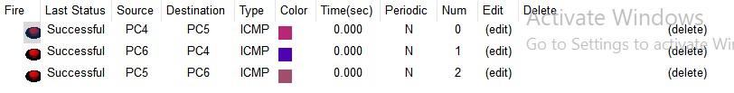
Between HQ data centres:
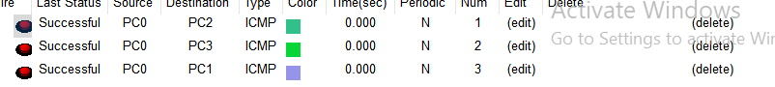
Between remote offices and the HQ data centre:
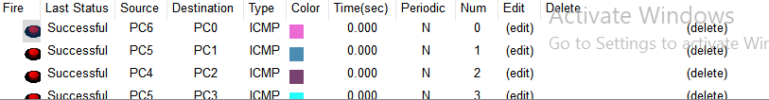

VPN/IPsec site-to-site connection:
As we have shown before in the picture between the remote offices and the HQ data centre, they ping each other and there is no problem.

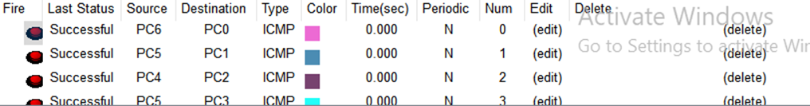

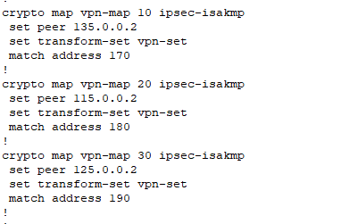
3-hardening test:
Passwords for all router and switch example:
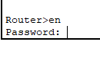
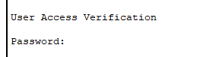
I apply ports security in every switch:
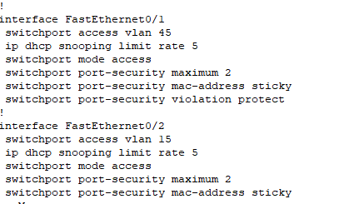

Routing test:
Between route Amman and all the remote offices:
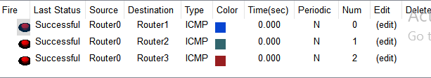
And router between the remote offices:
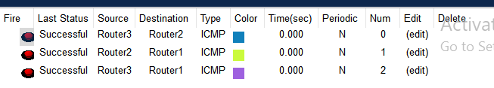

Between the router Amman and the firewall when I ping it give me failed and the same thing when I ping from the firewall to the firewall, I don’t know way I check the routing ospf and everything fine and configure in good way.

Local AAA authentication for SSH:
in router Tunisia:
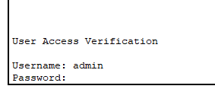
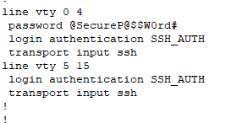

Disaster Recovery Site Tests (Aqaba Office):
SSH service on Aqaba ASA firewall is accessible only by HQ Datacentre PC1 (15.0.0.10):
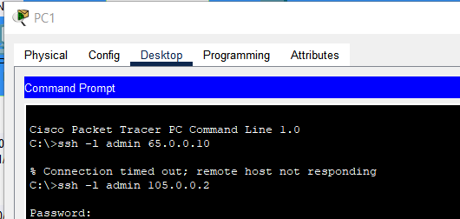

DMZ to inside ping failed and that what I want I don’t what the DMZ forward to inside:
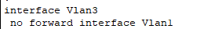
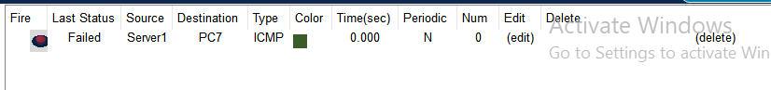

Firewall configuration test:
If I ping from the inside to the outside, it will success:
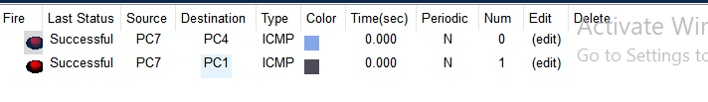
But if I ping from the outside to the inside, it will fail …. this is what we want because the security measure inside is higher than outside. (this is the advantage of the inspection)
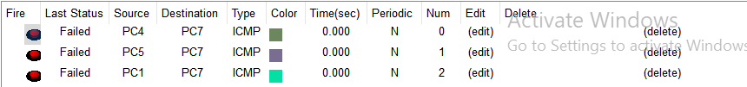

When I ping from the DMZ to the outside it success and that what we want because the seucirty measure of DMZ higher than the outside.
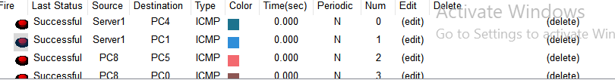

But the problem here if we want to ping from the outside to the DMZ, it fails Note that I put ACL in the firewall allowing outside to ping to the DMZ and brows.
Here the problem with routing because in pc in Kuwait when I ping to the DMZ it stops in router Kuwait and return back note that you can check in the ip running config I do the OSPF.

3. Critically evaluate the design, planning, configuration and testing of your network security.
Make some improvement recommendations?

The answer:
Some improvement recommendations:
1-Multi factor authentication:
Implement multi-factor authentication for critical system and services to add an extra layer of security beyond username and password.
2-IDPS:
Deploy intrusion detection and prevention systems to monitor network traffic for suspicious activities and automatically respond to or block potential threats.
3-encryption sensitive data:
Ensure that sensitive data is encrypted both in transit and at rest. Use encryption protocol such as TLS for data in transit and implement disk encryption for data at rest.

4-Review what is meant by Quality of Service (QoS) in relation to Network Security configuration
and how the security configuration can affect the Quality of Service?
The answer:
QOS:
Quality of services refer to the set of technology and mechanisms that prioritize and manage network traffic to ensure a certain level of performance reliability and availability for different types of data or applications.
Relation to network security:
QOS is crucial for optimizing network performance and ensuring that critical application receive the necessary resources and bandwidth.
Security configuration play a role in determining how QoS policies are implemented to maintain a balance between security and performance.

How security configuration affect QoS:
Traffic Prioritization:
QoS Aspect: Prioritizing particular traffic types.
Security Impact: Security settings effect vital traffic identification; for example, VoIP prioritizing may have an impact on security regulations that need seamless communication.

Bandwidth Allocation:
QoS Aspect: Allocate bandwidth for important applications.
Security Impact: Security methods, such as deep packet inspection, may consume bandwidth. Configurations must strike a balance between security and application demands.

Latency and delay:
QoS Aspect: Reduced latency for time-sensitive applications.
Security Impact: Security duties, such as SSL decoding, might cause slowness. Configurations are optimized for real-time app performance while ensuring security.
Resource utilization:
QoS Aspect: Efficient utilization of network resources.
Security influence: Security tasks, such as encryption, have an influence on resource use. Configurations strike a balance between security and preventing resource depletion, both of which effect QoS.

